Testing Method:
The testing method that I used was white box testing with a top to bottom method, I used it because I can make changes easily to the code to make sure it is fool proof.
Test Data:
Action | Expected | Result | Pass y/n?
Game Starts Up | Game starts up with a map drawn | 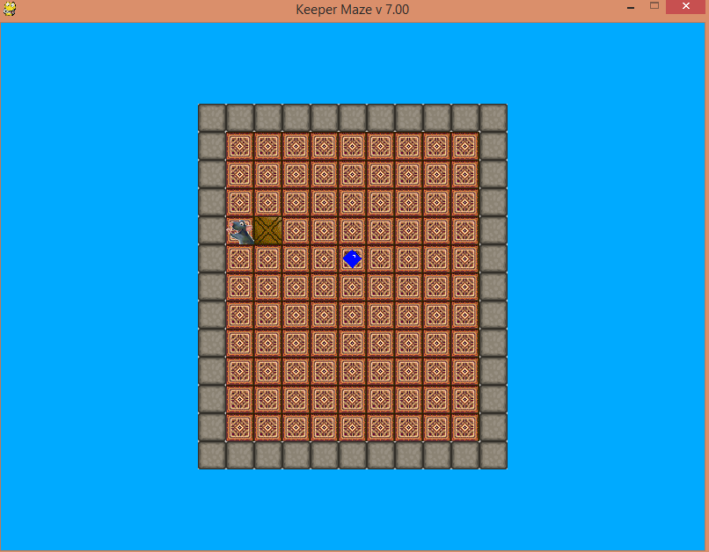 | y
Move Character down 1 space | Characters moves down a space | 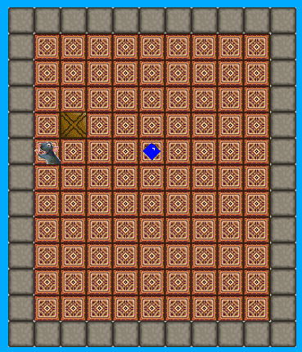 | y
Move Character Right once space | Character Moves to the Right One space | 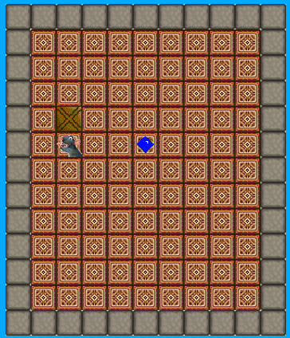 | y
Character moves up | Character Move Up | 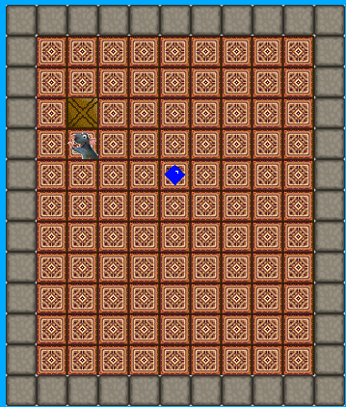 | y
Character Moves into Right Side wall | Character Does not pass through wall | 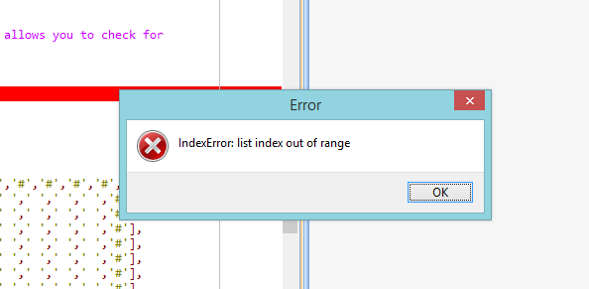 | n
Keeper Moves into right side wall | Keeper Does not pass through wall and No “IndexError” | 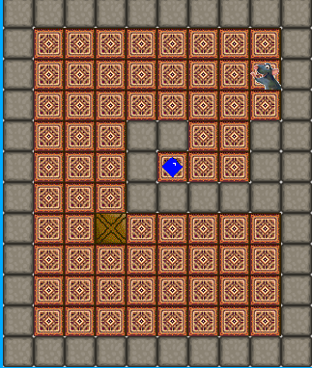 | y
Keeper Moves into left side wall | Keeper does not pass through wall | 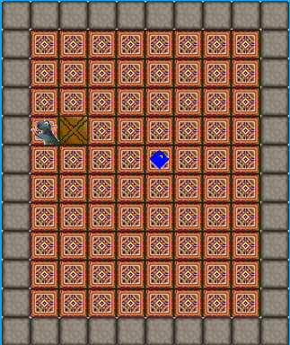 | y
Keeper Moves into bottom wall | Keeper does not pass through wall | 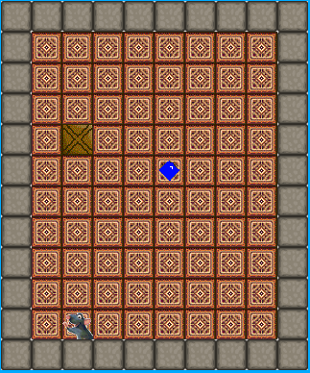 | y
Keeper Moves into top wall | Keeper does not pass through wall | 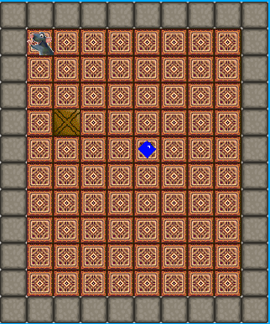 | y
Hitting Reset Button | Keeper to go back to default Position and Crate to go back to default Position | 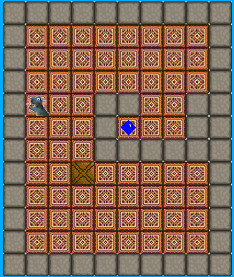 | n
Hitting Reset Button again. | Keeper to go back to default Position and Crate to go back to default Position | 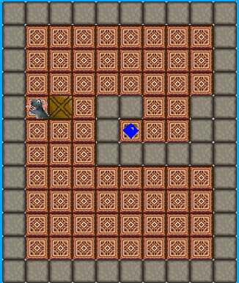 | y
Moving 5 Spaces to the right | Keeper moves 5 spaces to the right | 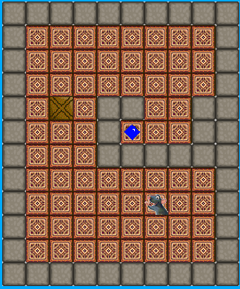 | y
Moving 5 spaces to the left into the wall | Keeper to move 5 spaces into the left wall without passing through |  | y
Moving 5 spaces to the right into the wall | Keeper to move 5 spaces into the right wall without passing through |  | y
Moving 5 spaces into upper wall | Keeper to move 5 spaces into the upper wall without passing through |  | y
Moving 5 spaces into lower wall | Keeper to move 5 spaces into the left wall without passing through |  | y
Level 2 Startup | Level 2 Loads | 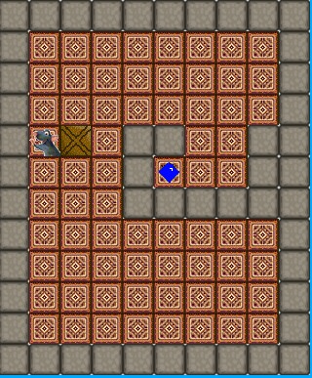 | y
Level 3 Startup | Level 3 Loads | 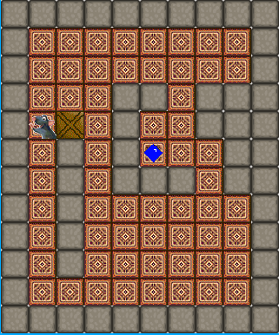 | y
Level 4 Startup | Level 4 Loads | 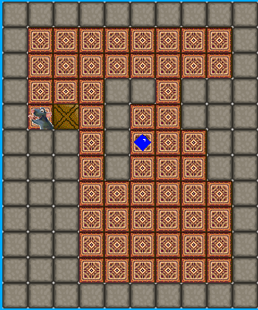 | y
Moves going up | Moves go up | 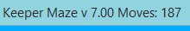 | y
Moves going to 300 | Moves go up to 300 | 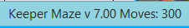 | y
Move crate into Left Wall | Crate does not move into wall | 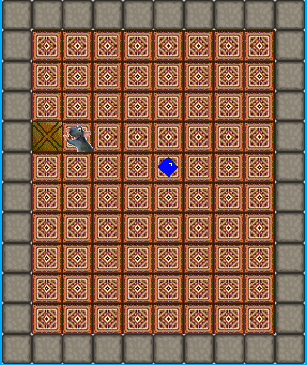 | y
Move crate into Right Wall | Crate does not move into wall | 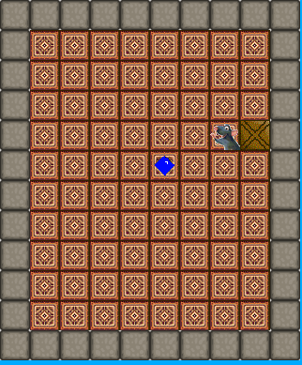 | y
Move crate into Upper Wall | Crate does not move into wall | 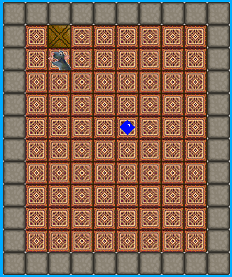 | y
Move crate into Lower Wall | Crate does not move into wall | 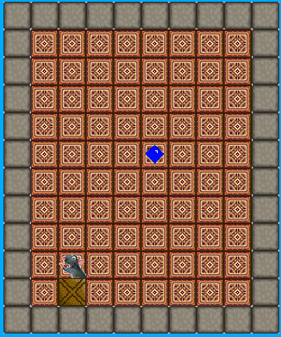 | y
Move Crate into left wall 10 times | Crate does not move into wall |  | y
Move Crate into Right wall 10 times | Crate does not move into wall |  | y
Move Crate into upper wall 10 times | Crate does not move into wall |  | y
Move Crate into lower wall 10 times | Crate does not move into wall |  | y

